TARGET GROUPS | All
TITLE | Cultral iceberg
RUNNING TIME | 30 minutes
LEARNING OBJECTIVES | To help identify those personal characteristics that are ‘visible’, ‘semi-visible’ and ‘not visible’ to us, as well as to show how we can use all types of characteristics to discriminate.
MATERIALS | Flipchart and markers
PREPARATION | Collect descriptors from the identity molecule game.
IMPLEMENTATION | Start by drawing an iceberg shape on the flipchart.  Using your results from the previous exercise (identity molecule), place your self-descriptive words on the iceberg. Characteristics about yourself that are visible to other members of our society without needing explanation, should go near the top of the iceberg. ‘Semi-visible’ characteristics should be found somewhere at or near water level, and ‘non-visible’ characteristics anywhere below, at different depths if you prefer. (See the example given on the next page.)  As the other participants are sharing their Cultural Bags or “I Am…” shapes, have them draw their own icebergs and place their self-descriptive words on the iceberg as you did your own.  Have a few different participants share their responses, and word placements with the rest of the group. Place their words on your iceberg as they share to allow all of the participants to compare the different results.
ROLE OF THE TEACHER | Facillitates the process
POSSIBLE RISKS & HOW TO HANDLE THEM | /
FEEDBACK TOOL | Debrief by bringing up the following discussion points and questions:  Q What pattern do you see on our iceberg?  Q Compare where participants placed their different traits.  Why did they choose the placements they chose?  Q Are there circumstances where someone might place a certain characteristic, such as religion, as a visible trait, and some circumstances where someone might place that  same characteristic as a non-visible trait? What are some other examples of when that sort of difference might occur?  Q There are some characteristics that are considered ‘visible’, such as your physical  capability, gender or ethnicity that may be used to discriminate against you because of  the system within which our society operates (refer to the definitions of sexism, racism, and ableism at the beginning of the manual.)  Q There are also some characteristics that are not visible, such as your sexual orientation, that may be used to discriminate against you because all it takes is someone to think or perceive that you may be gay, lesbian, bisexual or transgendered to make you a victim  of discrimination.  Q Many ships have sunk in history because the crews have misjudged the sizes of icebergs they have hit; all they could ever see was the tip of it (the visible things). They failed to recognize that below the surface of the water, the iceberg represented something much larger.

Q Example of where some characteristics might go (use actual self-descriptive words):

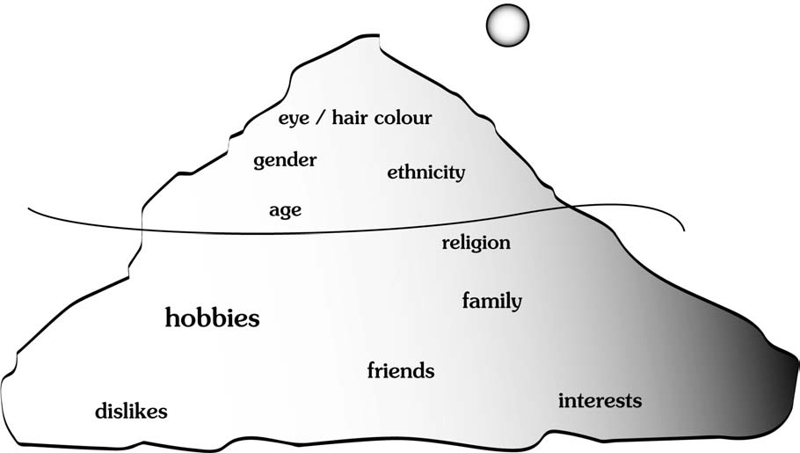

Adapted from People power booklet.

